Please complete your Home Profile below. If your home differs from the given defaults, please click on the section buttons on the left to select your inputs.

- Select the weather zone that best represents your area.
North Georgia
Atlanta Metro
Coastal Georgia
South Georgia

- Your Home Type
Click on the options below for more information.

Single Story | Townhouse End
Multi Story | Townhouse Mid
Split Level | Apt/Condo Lower Floor
Manufactured Home | Apt/Condo Top Floor

- Additional Information

Is your home on stilts/pilings?
  Yes | No
Do you have a basement level?
  Yes | No
If yes, is it a walk out/garage?
  Yes | No
Is it heated?
  Yes | No
Is it cooled?
  Yes | No

- Year Home Was Built
Select the year your home was built
1950 or Earlier
1951 to 1970
1971 to 1990
1991 to Present

- Home Size / Square Footage
Select the appropriate home size / square footage excluding your basement

Select the year your home was built
1500 or smaller
1500 to 2500
2500 to 3000
3000 or larger

- Air Leaks
Click on the options below for more information

Drafty/Street noise
Typical / Don't Know
Weatherized by homeowner
Weatherized by professional
- Typical Air Infiltration
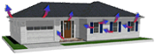Select Typical if your home has not been weatherized recently (caulk and weather stripping). You should not be able to feel drafts or hear a lot of street noise.

Do you believe ducts in your home need repair?
  Yes | No

Insulation Information
Select insulation for your walls, ceilings and floors

- Wall Insulation
I Don't Know
Uninsulated
Typical 4" Wall (R11)
Typical 6" Wall (R19)
Spray Foam (R30)


- Ceiling Insulation
I Don't Know
Uninsulated
Typical 4" Batts (R11)
Typical 6" Batts (R19)
9.5" Batts (R30)
12" Deep (R38)

- Floor Insulation
I Don't Know
Slab
Uninsulated
Typical 4" Batts (R11)
Typical 6" Batts (R19)
Spray Foam (R30)

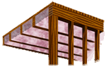

- Window Panes
Click on the options below for more information

Single Pane
Double or Single w/Storm Windows
Triple Pane or Low-E

Single Pane
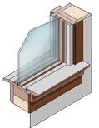One pane of glass surrounded by a frame. The frame may be movable or fixed.
- Window Type
Select your window style below

Double Hung
Single Hung
Casement
Jalousie/Awning
Sliding
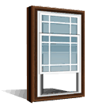

- Window Size
Select your home's glass % below

Small Windows
Standard Size Windows
Large Windows
Very Large Windows
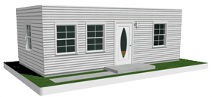

- Primary Heating
System Type
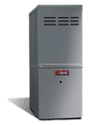
Age of System
0 to 4 yeas
4 to 8 years
8 to 12 years
13 years or older

Heating Setting *
68 to 70
71 to 75
76 to 80
81 degrees or higher

- Primary Cooling
System Type
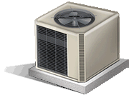
Age of System
0 to 4 yeas
4 to 8 years
8 to 12 years
13 years or older

Cooling Setting *
60 to 69
70 to 79
No AC

- Water Heater
Choose your water heater type, location and water temperature

None | Nat. Gas - High Eff.
Electric | Nat. Gas - Tankless
Electric - High Eff. | Propane
Heat Pump | Solar
Natural Gas | Supplied by Landlord

0 to 3 yeas | Water Heater Age
4 to 7 years
8 to 12 years
13 years or older

Electric Water Heater
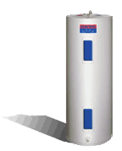
Electric water heaters are storage tanks with an electrical connection and no venting to the outside. They range in size from just a few gallons up to 80 gallons.
- Refrigerators
Identify your primary refrigerator and any other refrigerators in the home

Primary Refrigerator
Type
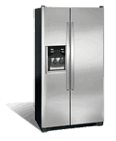
Age
0 to 5
5 to 10 years
10 to 15 years
15 years or older

- Freezers
Identify your primary freezer and any other freezers in the home

Primary Freezer
Type
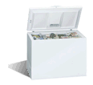
Age
0 to 5
5 to 10 years
10 to 15 years
15 years or older


- Televisions
Please identify the primary TVs in your home
TV Type
Flat Screen
Tube
Projection
No television

Quantity
0 to 2
2 to 4
4 to 6
6 or greater

- Cooking
Please choose your cooking type

Cooking Type
None
Electric
Natural Gas
Propane

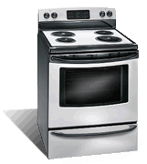

How often do you cook?

Once A Day
Twice A Day
Three Times A Day
More Than Three

- Dishwasher
Please choose your dishwasher

Dishwasher Type
None
Electric
Energy Star
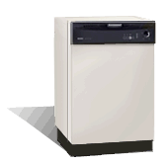

- Clothes Washer
Please choose your clothes washer

Clothes Washer Type
None
Electric
Energy Star - Top Load
Energy Star - Front Load
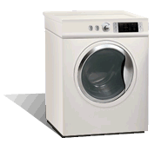
Loads per week

0 to 2
2 to 4
4 to 6
6 loads or more

- Clothes Dryer
Please choose your clothes dryer

Clothes Dryer Type
None
Electric
Natural Gas
Propane
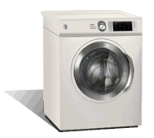

Loads per week

0 to 2
2 to 4
4 to 6
6 loads or more

- Swimming Pool
If your home has a pool, please select 'Yes' and complete the attributes

Do you have a pool? YesNo

Pool Attributes
Pump Hours

0 to 2
2 to 4
4 to 6
6 loads or more

Heating Temperature

Low
Medium
High
No Heater

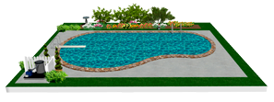

- Hot Tub
If your home has a hot tub, please select 'Yes' and complete the attributes

Do you have a hot tub? YesNo

Hot Tub Attributes
Hours Used/Day

0 to 2
2 to 4
4 to 6
6 or more hours

Heating Temperature

Low
Medium
High
No Heater

